**1.INTRODUCTION**

This paper mainly focuses on the controlling of home appliances remote and providing security when the user is away from the place. The system is SMS based and uses wireless technology to revolutionize the standards of living. This system provides ideal solution to the problems faced by home owners in daily life. The system is wireless therefore more adaptable and cost-effective. The HACS system provides security against intrusions well as automates various home appliances using SMS. The system uses GSM technology thus providing ubiquitous access to the sys-tem for security and automated appliance control.

The aim of the paper is to investigate a cost effective solution that will provide controlling of home appliances remotely and will also enable home security against intrusion in the absence of home owner. The motivation is to facilitate the users to automate their homes having ubiquitous access. The system provides availability due to development of a low cost system. The home appliances control system with an affordable cost was thought to be built that should be mobile providing re-mote access to the appliances and allowing home security. Home security has been a major issue where crime is increasing and everybody wants to take proper measures to prevent intrusion. In addition there was a need to automate home so that user can take advantage of the technological advancement in such a way that a person getting off the office does not get melted with the hot climate. Therefore this paper proposes a system that allows user to be control home appliances ubiquitously and also provide security on detection of intrusion via SMS using GSM technology.

**2. SYSTEM ANALYSIS**

System analysis is done in order to understand the problem the embedded system is to solve. This emphasis in system analysis is on identifying what is needed from the system, not how the system will achieve the goal. A system is a set of components that interact to accomplish some purpose.

* Identifying the drawback of the existing system.
* Identify the need for conversion.
* Perform feasibility study.
* Identify hardware ,software and database requirements.
* Create system definition that forms foundation for subsequent work.

**2.1 SYSTEM DESCRIPTION**

System description is a detailed study over the system and various operations performed by the system and their relations within and outside of the system. Here it is simply finding out what happen in the existing system deciding what changes are to be made when new features are added. This is the standard procedure to organize and co-ordinate the standard procedure of the system. The first step is to study and analyze the problem to be solved. Besides the interview, a detailed study on written documents, student evaluation profile, were carried out to understand what changes are needed from the requested and to examine whether another system can fulfil the request made. The system analysis revealed the facts, which made the system complex and tempted the users to think about another, they are

* Manual processing cause time wastage
* Recording of data were not easier.
* Retrieval of data were not easier
* Speed on data retrieval was low.
* Since it is complex to understand.
* It may generate errors.

**SOFTWARE REQUIREMENTS**

1. Operating System - Microsoft Windows 7

2. AVR studio - For controller programming

3. Proteus 8 - For circuit and PCB design

4. Khazama AVR programmer - For PC interface programming

**HARDWARE REQUIREMENT**

1.ATMega32 Microcontroller

2.GSM

3.MAX232

4. Motor

5. PC interfacing

6. LCD with driver

7. Regulated power supply

8. Crystal oscillator

**AVR STUDIO 5.0**

AVR Studio 5 is the new integrated development environment from Atmel. It provides you a modern and powerful environment for doing AVR development. All 8-bit and 32-bit microcontrollers are supported. Get started by exploring the included example projects. Run your solution on a starter or evaluation kit. Program and debug your project with the included simulator, or use one of the powerful on-chip debugging and programming tools from Atmel. Get productive with the various navigate, refactor and intellisense features in the included editor. Experience seamless integration with various Atmel WEB services like Atmel Video Lounge, Atmel Store and datasheets to keep you updated and help you to design your solutions. With strong extension possibilities and online gallery, it is possible for both designers and 3rd party to provide plug-ins and customize the environment for best use and productivity.

AVR Studio 5 carries and integrates the AVR GCC tool chain AVR SoftwareFramework, assembler and simulator. All newest Atmel tools are supported including AVR ONE!, JTAGICE mkII, JTAGICE3, STK500, STK600, QT600, AVRISP mkII and AVR Dragon.

**SYSTEM REQUIREMENTS**

**Supported Operating Systems**

 Windows XP (x86) with Service Pack 3 - all editions except Starter Edition

 Windows Vista (x86) with Service Pack 1, Service Pack 2 - all editions except Starter Edition

 Windows XP (x64) with Service Pack 2

 Windows Vista (x64) with Service Pack 1, Service Pack 2

 Windows 7 (x86 and x64)

 Windows Server 2003 R2 (x86 and x64)

**Hardware Requirements:**

 Computer that has a 1.6GHz or faster processor

 1 GB RAM for x86

 2 GB RAM for x64

 An additional 512 MB RAM if running in a Virtual Machine

 3GB of available hard disk space

 5400 RPM hard disk drive

 DirectX 9-capable video card that runs at 1024 x 768 or higher display resolution

Notable bugs fixed

 AVRSV-2703:

Default option to preserve EEPROM prohibits chip erase from AVR Programming.

 AVRSV-2688:

Fail to start debugging if there is a custom SRAM section in object file.

 AVRSV-2643:

Artifact name from Project Properties 'Build' section is not passed correct to the linker.

 AVRSV-2621:

This assembler is incapable of decoding the unique 1-word 'lds' and 'sts' instructions found in the

ATtiny10/9/5/4/20/40 devices.

 AVRSV-2618:

Inconsistent behavior when single stepping using the AVR Dragon and JTAGICE mkII.

 AVRSV-2617:

Fail to program an elf-file using AVR Programming if the elf-file does not contain a 'main' entry.

 AVRSV-2609:

Memory segment settings is not copied when opening an existing 5.0 bootloader project in 5.1.

 AVRSV-2605:

Memory directives is not handled correctly.

 AVRSV-2598:

Link files inside sub directories are not compiled.

 AVRSV-2595:

StudioCommandPrompt.exe crash on unhandled exception.

 AVRSV-2561:

Linker option '-nodefault' is not supported.

 AVRSV-2533:

Dependencies folder is not getting populated for C++ projects when the project is built.

 AVRSV-1530:

Code size summary should be a part of the output when building a project.

 AVRSV-1770:

An installation of Visual Studio may be broken after AVR Studio 5 is installed on the same machine

**New AVR Studio 5.1**

 New version of AVR Software Framework (ASF), version 2.9.0

 Availability and installation of new ASF versions through extension manager, without having to upgrade Studio 5

 Support for side by side versioning of ASF, with the ability to upgrade projects

 Syntax highlighting and better debugging support for C++ projects

 Support for importing AVR 32 Studio C++ projects

 New version of AVR Tool chain, version 3.3.1

 New command line utility (at program) with support for all Atmel AVR tools and devices

 Enhancements to programming dialog including support for ELF programming

 New version of Visual Assist with several enhancements and bugfixes

 Support for 55 new devices



**Simplified view of AVR microcontroller**

**PROTEUS 8 PROFFESSIONAL**

Proteus is a best simulation software for various designs with microcontroller. We choose this because of availability of almost all microcontrollers in it. So it is a handy tool to test programs and designs for electronics hobbyist. we can simulate our programming of microcontroller in Proteus Simulation Software .After Simulating circuit in Proteus Software we can directly make PCB design with it so it could be an all in one package for all users.

Proteus is a high-performance simulator for MIMD multiprocessors. It is fast, accurate, and exible: it is one to two orders of magnitude faster than comparable simulators, it can reproduce results from real multiprocessors, and it is easily configured to simulate a wide range of architectures. Proteus provides a modular structure that simplifies customization and independent replacement of parts of architecture. There are typically multiple implementations of each module that provide different combinations of accuracy and performance; users pay for accuracy only when and where they need it. Finally, Proteus provides repeatability, nonintrusive monitoring and debugging, and integrated graphical output, which Result in a development environment superior to those available on real multiprocessors.

Proteus is an execution-driven simulator [CMM+88]; it multiplexes a single processor among the various activities in a simulated parallel machine to provide accurate information about the timing and behaviour of an application and the underlying simulated architecture. Proteus is fast, accurate, and exible: it is one to two orders of magnitude faster than comparable simulators, it can reproduce results from real multiprocessors, and it is easily configured to simulate a wide range of MIMD architectures. Proteus' modular structure allows users to trade-off accuracy and performance: users pay for accuracy only when and where they need it. The structure also allows easy customization of the architecture. Finally, Proteus provides repeatability and nonintrusive monitoring and debugging, which result in a development environment superior to those available on real multiprocessors.

We believe that simulation has a valuable role to play at all levels of the design and analysis of multiprocessor systems, from architectures to runtime systems to algorithms and applications. Many projects have used simulation during the development of new architectures to guide the design. We believe that simulation has an equally vital role to play in the development of software systems for multiprocessors. There are two alternatives to simulation: analytical modelling and using real machines. Multiprocessor systems are sufficiently complex that analytical modelling is difficult. On the other hand, using a real machine to test, debug, and tune a program is problematic. In contrast, simulation allows nonintrusive monitoring and debugging, and also makes it easy to repeat executions so that different phenomena in an execution can be studied at a variety of levels of detail. Another important advantage of simulation is exibility. Using a simulator such as Proteus, we can study the behaviour of a program on much different architecture. For example, alternative memory systems can be simulated, giving insight into the

Interactions among applications, compilers, and cache-management techniques. Similarly, the number of processors can be varied, giving insight into the scalability of a program or algorithm (perhaps well beyond the limits imposed by real machines). For all its advantages, simulation has potential problems in two areas speed and accuracy that can make it less useful. First, simulators are often slow, making it impossible to run large experiments or sets of experiments. Second, simulators are often inaccurate, making it difficult to draw useful conclusions from the results of a simulation. Proteus is an execution-driven simulator that interleaves the execution of an application program with the simulation of the underlying architecture; this makes it possible to achieve very high accuracy. In addition, Proteus avoids interpreting user application code whenever possible, thus removing the overhead of interpretation for most instructions. Proteus is also designed so that the entire simulation system, including the application program and the network and memory simulators, runs in a single address space. Another important feature of Proteus is the ability it provides the user to control the level of accuracy of the simulation. In general, there is a trade-off\_ between accuracy and performance: a more accurate simulation requires more time. Since the level of accuracy desired and the amount of information needed from a simulation depend on the application, Proteus provides users with unprecedented exibility in choosing or customizing the level of accuracy in the network and memory simulations. The User can also control what monitoring data is produced, both for system-level data (e.g., shared-memory traces) and user-level data (e.g., the time spent in a code section or the size of a data structure). As discussed in more detail below, changing the level of accuracy of the simulation makes a large difference in the running time. For users who need large simulations or sets of simulations, it is important that they be able to pay only for the accuracy they need. Proteus was originally designed for evaluating language, compiler, and runtime system mechanisms

to support portability; thus, exibility, accuracy, and performance are all important. We have also used it for algorithmic and architectural studies, including concurrent search trees and network and cache research [CBDW91]. In general, Proteus is an excellent development platform for parallel software: it supports testing and debugging, performance evaluation and tuning, and graphical output.

**Modules :-**

Proteus was designed with a modular structure to simplify replacement and customization of specifies parts of the simulator. The modular structure provides two very important abilities. First, the structure simplifies customizing the target architecture: it is very easy to experiment with part of the architecture while keeping the rest unchanged. This makes Proteus useful for evaluating architectural design decisions, and for simulating specifies multiprocessors. Second, the modular structure promotes multiple implementations of a given module, which allows users to switch between very accurate versions and very fast versions. Users pay only for what they need; in particular, the high-performance versions greatly reduce development The operating system module provides a kernel operating system for the simulated multiprocessor. The kernel interface specifies procedures for thread scheduling and management, memory management, and interrupt and trap handling. In addition to the kernel interrupt handlers, users may define their own interprocessor interrupts (IPIs) and handlers; for example, user-defined IPIs are used to build dispatch routines for message-passing architectures.

The shared-memory module provides access to local shared memory, handles full-empty bits, and provides atomic operations such as test-and-set and compare-and test. The shared memory of a remote processor is not accessed directly via the shared-memory module; instead, a network request is generated (usually by the cache module) that invokes the shared-memory module when it arrives at the remote node. Separating the remote access into a network portion and a local-memory portion allows the network and shared-memory modules to be replaced independently. The cache module handles memory requests from the local processor and from the local network chip. It generates calls to both the shared-memory module (for local accesses) and the network module (for remote accesses). The primary operations provided by the cache module are read, write, and use. In addition, the module defines operations for software coherence: soft read and write, and fence [SS87]. The intent of the soft operations is to access the currently cached, possibly stale, data. The fence operation blocks until all pending protocol transactions for the given cache lines have completed and are used to ensure coherence for that cache line. The network module, described in detail in the next subsection, simulates the movement of data within the interconnection medium.

Processor is ready to send a packet to the network chip. The second type of request is the route request, which computes the next node for a packet and computes the arrival time of the packet at that node. Some versions, such as a bus, do not use this request at all. The third type is the receive request, which occurs when the packet reaches the target node. The receive request either interrupts the processor or notifies the cache chip depending on the packet. Only the network module generates route and receive requests; all other modules generate only send requests. Table 1 lists the procedures for generating and executing network requests. New versions of the network module only need to replace the procedures for executing network requests.

**Trading Accuracy for Performance:-**

Depending on the end goals of a simulation, some modules may have to be very accurate while others can be less accurate. For example, users studying scheduling require very accurate costs in the operating systems module but may not need detailed network simulation. Furthermore, during development, users generally prefer to avoid the lower performance of the most accurate modules. The ability to replace modules provides a simple way to trade accuracy for performance: Proteus provides both a very accurate version of a module and a high-performance version with the same semantics but lower accuracy.

**Direct Execution**

A primary factor in the performance of Proteus is the use of direct execution to provide very low-overhead simulation of most instructions. The key idea is to execute local instructions directly and augment the code with cycle-counting instructions to time the code. This section presents an overview of direct execution with augmentation and discusses the exibility it provides and the assumptions it requires. Proteus directly executes local instructions. An instruction is local if it only affects the local processor. For example, all register-to-register instructions are local instructions. An instruction that might affect another part of the system is a non-local instruction. All shared-memory accesses and network instructions are non-local. Proteus simulates local instructions by directly executing the instruction on the host workstation; non-local instructions are simulated via a procedure call.

**Monitoring and Debugging :-**

In addition to performance, a primary asset of Proteus is its support for monitoring and debugging. Proteus provides nonintrusive monitoring and debugging: users can add monitoring code that does not afiect the behavior or timing of the simulation. Proteus also provides repeatability: users can rerun simulations to pinpoint bugs. Real multiprocessors generally provide neither of these abilities. Because Proteus runs as a single process, it works well with sequential debuggers such as dbx [Lin90]. This extends the power of advanced sequential debuggers to the parallel parallel development arena. Further more, Proteus provides an internal debugging mode that allows users to examine the states of threads, processors, locks, and memory. Combining the Proteus debugger with a sequential debugger such as dbx results in a very efiective development environment. Proteus also provides an integrated subsystem for data collection and display. Data collection is supported by primitives for recording data to a trace file and by user-defined data types. Data display is performed by an X-based graph program that uses a simple but powerful graph language to interpret the trace file data. This section examines Proteus' support for nonintrusive monitoring and discusses repeatability and no determinism. It then examines the primitives for data collection and concludes with a discussion of the graph-generation program.

**Data Collection :-**

The ability to collect exactly the desired data greatly enhances the usefulness of simulation. Proteus provides a framework for generating trace file data that allows users to generate their own data in addition to the statistics collected by the engine and the modules. The simulator uses two basic kinds of data, time-dependent and time-independent. The time dependent data records, called events, include a value, an index, and a timestamp. For example, a concurrency graph can be generated using events: each point is an event consisting of the number of busy processors and the timestamp.9 Any graph that plots something versus time uses events.

**Performance :-**

Proteus substantially outperforms comparable multiprocessor simulators. By providing one to two orders of magnitude improvement in performance, Proteus allows researchers to investigate applications and machine sizes prohibited by the performance of other simulators.

**ATMEGA 32**

* High-performance, Low-power Atmel®AVR® 8-bit Microcontroller
* Advanced RISC Architecture
  + 131 Powerful Instructions – Most Single-clock Cycle Execution
  + 32 × 8 General Purpose Working Registers
  + Fully Static Operation
  + Up to 16 MIPS Throughput at 16MHz
  + On-chip 2-cycle Multiplier
* High Endurance Non-volatile Memory segments
  + 32Kbytes of In-System Self-programmable Flash program memory
  + 1024Bytes EEPROM
  + 2Kbytes Internal SRAM
  + Write/Erase Cycles: 10,000 Flash/100,000 EEPROM
  + Data retention: 20 years at 85°C/100 years at 25°C
  + Optional Boot Code Section with Independent Lock Bits
* In-System Programming by On-chip Boot Program
* True Read-While-Write Operation
  + Programming Lock for Software Security
* JTAG (IEEE std. 1149.1 Compliant) Interface
  + Boundary-scan Capabilities According to the JTAG Standard
  + Extensive On-chip Debug Support
  + Programming of Flash, EEPROM, Fuses, and Lock Bits through the JTAG Interface
* Peripheral Features
  + Two 8-bit Timer/Counters with Separate Prescalers and Compare Modes
  + One 16-bit Timer/Counter with Separate Prescaler, Compare Mode, and Capture

Mode

* + Real Time Counter with Separate Oscillator
  + Four PWM Channels
  + 8-channel, 10-bit ADC
* 8 Single-ended Channels
* 7 Differential Channels in TQFP Package Only
* 2 Differential Channels with Programmable Gain at 1x, 10x, or 200x
  + Byte-oriented Two-wire Serial Interface
  + Programmable Serial USART
  + Master/Slave SPI Serial Interface
  + Programmable Watchdog Timer with Separate On-chip Oscillator
  + On-chip Analog Comparator
* Special Microcontroller Features
  + Power-on Reset and Programmable Brown-out Detection
  + Internal Calibrated RC Oscillator
  + External and Internal Interrupt Sources
  + Six Sleep Modes: Idle, ADC Noise Reduction, Power-save, Power-down, Standby and Extended Standby
* I/O and Packages
  + 32 Programmable I/O Lines

40-pin PDIP, 44-lead TQFP, and 44-pad QFN/MLF

* Operating Voltages
  + 2.7V - 5.5V for ATmega32L
  + 4.5V - 5.5V for ATmega32
* Speed Grades
  + 0 - 8MHz for ATmega32L
  + 0 - 16MHz for ATmega32
* Power Consumption at 1MHz, 3V, 25°C
  + Active: 1.1mA
  + Idle Mode: 0.35mA
  + Power-down Mode: < 1μA

**Pinout :-**

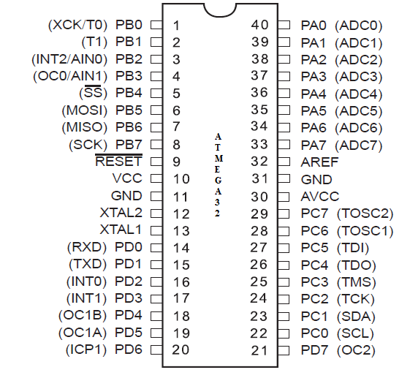

The Atmel@AVR core combines a rich instruction set with 32 general purpose working registers. All the 32 registers are directly connected to the Arithmetic Logic Unit (ALU), allowing two independent registers to be accessed in one single instruction executed in one clock cycle. The resulting architecture is more code efficient while achieving throughputs up to ten times faster than conventional CISC microcontrollers. The ATmega32 provides the following features: 32Kbytes of In-System Programmable Flash Program memory with Read-While-Write capabilities, 1024bytes EEPROM, 2Kbyte SRAM, 32 general purpose I/O lines, 32 general purpose working registers, a JTAG interface for Boundaryscan, On-chip Debugging support and programming, three flexible Timer/Counters with compare modes, Internal and External Interrupts, a serial programmable USART, a byte oriented Two-wire Serial Interface, an 8-channel, 10-bit ADC with optional differential input stage with programmable gain (TQFP package only), a programmable Watchdog Timer with Internal Oscillator, an SPI serial port, and six software selectable power saving modes. The Idle mode stops the CPU while allowing the USART, Two-wire interface, A/D Converter, SRAM, Timer/Counters, SPI port, and interrupt system to continue functioning. The Power-down mode saves the register contents but freezes the Oscillator, disabling all other chip functions until the next External Interrupt or Hardware Reset. In Power-save mode, the Asynchronous Timer continues to run, allowing the user to maintain a timer base while the rest of the device is sleeping. The ADC Noise Reduction mode stops the CPU and all I/O modules except Asynchronous Timer and ADC, to minimize switching noise during ADC conversions. In Standby mode, the crystal/resonator Oscillator is running while the rest of the device is sleeping. This allows very fast start-up combined with low-power consumption. In Extended Standby mode, both the main Oscillator and the Asynchronous Timer continue to run.

RTC - DS1307

**General Description :-**

The DS1307 serial real-time clock (RTC) is a low-power, full binary-coded decimal (BCD) clock/calendar plus 56 bytes of NV SRAM. Address and data are transferred serially through an I2C, bidirectional bus. The clock/calendar provides seconds, minutes, hours, day, date, month, and year information. The end of the month date is automatically adjusted for months with fewer than 31 days, including corrections for leap year. The clock operates in either the 24-hour or 12-hour format with AM/PM indicator. The DS1307 has a built-in power-sense circuit that detects power failures and automatically switches to the backup supply. Timekeeping operation continues while the part operates from the backup supply.

**Benefits And Features :-**

* Completely Manages All Timekeeping Functions
* Real-Time Clock Counts Seconds, Minutes, Hours, Date of the Month, Month, Day of the Week, and Year with Leap-Year Compensation Valid Up to 2100
* 56-Byte, Battery-Backed, General-Purpose RAM with Unlimited Writes
* Programmable Square-Wave Output Signal
* Simple Serial Port Interfaces to Most Microcontrollers
* I2C Serial Interface
* Low Power Operation Extends Battery Backup Run Time
* Consumes Less than 500nA in Battery-Backup Mode with Oscillator Running
* Automatic Power-Fail Detect and Switch Circuitry
* 8-Pin DIP and 8-Pin SO Minimizes Required Space
* Optional Industrial Temperature Range: -40°C to +85°C Supports Operation in a Wide Range of Applications
* Underwriters Laboratories® (UL) Recognized

**Pinout :-**

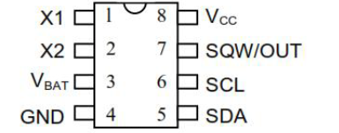

**LCD**

Alphanumeric displays are used in a wide range of applications, including palmtop computers, word processors, photocopiers, point of sale terminals, medical instruments, cellular phones, etc. The 16 x 2 intelligent alphanumeric dot matrix display is capable of displaying 224 different characters and symbols. A full list of the characters and symbols is printed on pages 7/8 (note these symbols can vary between brand of LCD used). This booklet provides all the technical specifications for connecting the unit, which requires a single power supply (+5V).

Available as an optional extra is the Serial LCD Firmware, which allows serial control of the display. This option provides much easier connection and use of the LCD module. The firmware enables microcontrollers (and microcontroller based systems such as the PICAXE) to visually output user instructions or readings onto an LCD module. All LCD commands are transmitted serially via a single microcontroller pin. The firmware can also be connected to the serial port of a computer.

**Features Of Lcd :-**

* Interface with 8-bit or 4-bit MPU
* 192 kind of alphabets, numerals, symbols and special characters are displayed.
* Low power consumption
* If interface data is 4-bit long data transfer are made through 4 bus line from DB7 to DB4.

**2.2 SCOPE OF THE PROJECT**

Information technology plays a key role in codifying knowledge and distributing it throughout the organization .Systems are created to solve problems. The system analysis and design mainly deals with the software development activities.

The proposed system is developed to overcome the drawbacks of the existing system. The main objective of the project is to control the home appliances from remote area according to the user wish .There are many devices for controlling devices but they are expensive.So here we use all basic components like GSM,SIM, mobile etc… to make our project easier. Remote control technologies are widely used to control household electronic appliances without walking up to them. The advantage of cellular technology is a potential solution for remote controlling activities.

**2.3 EXISTING SYSTEM**

Controlling household appliances through computer is usually used system. There are many home wireless based devices for controlling but they are very expensive. . Remote control technologies are widely used to control household electronic appliances without walking up to them. These type of devices are used in large IT companies for controlling wastage of power. But those existing devices are expensive and utilise more power and time.

**DISADVANTAGES:**

* Maximum power and time utilisation.
* Expensive.
* Difficult to manage.
* It cannot fulfill the current demand which is to control from remote places

**2.4 PROPOSED SYSTEM**

Remote control technologies are widely used to control house hold electronic appliances without walking with them .Here we use all basic components such as SIM,GSM,MOBILE etc. to make our project more easier and costless. In this project we used to coordinate appliances and other devices using SMS. The GSM efficiently receive and transmit data via sms.Thus it

minimize power and time utilisation.

**2.5 ADVANTAGES**

* Simple and easy to access.
* Portable
* Access from remote area.
* Low power consumption.
* Taking measure to reduce electricity

**2.6 FUNCTIONAL REQUIRMENTS**

The need for this project arose due to the difficulty in existing inverter system. The existing system requires large human effort and attention. But the proposed system works based on certain priority. That means all devices connected to the inverter assigns priority and they works based on that assigned priority.

**DEVELOPER RESPONSIBILITIES**

* Assign priority to all devices in the inverter
* Turnoff the devices automatically

**OUTPUT DEFINISION**

The outputs should be defined in terms following points:

* Type of the output
* Content of the output
* Format of the output
* Location of the output
* Frequency of the output
* Volume of the output
* Sequence of the output

It is not always desirable to print or display data as it is held on a computer.

It should be decided as which form of the output is the most suitabl**e.**

**OUTPUT MEDIA**

In the next stage it is to be decided that which medium is the most appropriate for the output. The main considerations when deciding about the output media are:

* The suitability for the device to the particular application.
* The need for a hard copy.
* The response time required.
* The software and hardware available.

Keeping in view the above description the project is to have outputs mainly coming under the category of internal outputs. The main outputs are desired according to the requirement specification. The outputs were needed to be generated as a hot copy and as well as queries to be viewed on the screen. Keeping in view these outputs, the format for the output is taken from the outputs, which are currently being obtained after manual process. The standard printer is to be used as output media for hardcopies.

**INPUT DESIGN**

Input design is a part of overall system design. The main objectives : -

* To produce cost- effective method of input.
* To achieve the highest possible level of accuracy.
* To ensure that input is acceptable and understood by the user.

**INPUT STAGES**

The main input stages can be listed as below:

* Data recording
* Data transcription
* Data conversion
* Data verification
* Data control
* Data transmission
* Data validation
* Data correction

**INPUT TYPES**

It is necessary to determine the various types of inputs. Inputs can be categorized as follows:

* External input, which are prime inputs for the system.
* Internal inputs, which are user communication with the system.
* Operational, which are computer department’s communications.
* Interactive which are inputs entered during a dialogue.

**INPUT MEDIA**

At this stage choice has to be made about the input media. To conclude about the input media consideration has to be given to:

* Type of inputs
* Flexibility of format
* Speed
* Accuracy
* Verification methods
* Rejection rates
* Ease of correction
* Storage and handling requirements
* Security
* Easy to use
* Portability

ERROR AVOIDANCE

At the stage care is to be taken to ensure that input data remains accurate form the stage at which it is recorded up to the stage.

3.**SYSTEM DESIGN**

An embedded system is one with computing hardware that has software “embedded” in it as one of its core components.  We are surrounded by embedded systems that add luxury to our lives like mobile handsets, washing machines, microwaves, ATM machines, and air conditioners, to name just a few.  Because of certain application requirements, engineers have to approach embedded design in a different way than other types of designs.

The following offers a brief step-by-step approach to follow while designing an embedded system:

**1 PROPOSAL**

An innovative idea or system that makes life easier and/or reduces the amount of human effort required to complete a task.

**2 DEFINITION**

Next, the whole system needs to be designed, including what it will do under all possible sets of input conditions. This definition is perhaps the most critical part, as any error here will affect the working of whole system.

I/O Considerations: - Defines that for a particular input, what the output of the system will be,    considering the system as a black box.

Mathematical Modeling: - Design the algorithm for the system to work as desired.

Functional Modeling: - Design the functions of the system which will accept input and produce the desired output.

**3.TECHNOLOGY SELECTION**

Based on the above points, designers then review available technology and select which devices will fulfill all the requirements while balancing efficiency, cost, and time-to-market.

**4. INTEGRATION & PCB DESIGN**

List all the components, which you need to implement your functions and design their placement on the PCB. Traces and all other paths must have the least possible electromagnetic interference (EMI) and should be free from various errors. While designing the PCB, special attention must be given to the ground as well as all the components on the PCB that use ground.

**5. FIRMWARE DEVELOPMENT & DEBUGGING**

Since hardware needs instructions to execute the way we want, we need to write the code for every component used by the hardware. This is exactly what is done by the firmware i.e. the application code. Firmware should be of minimum complexity. Moreover, as we write the code, we face many errors or bugs and for this we need a proper debugging protocol.

**6. TESTING**

Debugging tests the piece of code but in testing we test the whole system i.e. hardware as well as the software that drives that hardware.

**7. DOCUMENTATION**

Anyone who accesses your complete application should never ask you “what does this mean?” or “How does this thing work?” and for this we need to document   everything.

**3.1 DFD WITH DETAILED EXPLANATION**

Data Flow Diagram is a way of expressing system requirements in a graphical form. It has the purpose of identifying major transformation that will become programs in system design. A Data Flow Diagram (DFD) or a Bubble chart is a graphical tool for structured analysis. DFD models a system by using external entities from which data flows to a process, which transforms the data and creates, output-data-flows which go to other processes or external entities or files. There are various symbols used in a DFD. Bubbles represent the processes. Named arrows indicate the data flow. External entities are represented by rectangles and are outside the system such as vendors or customers with whom the system interacts. They either supply or consume data. Entities supplying data are known as sources and those that consume data are called sinks. Data are stored in a data store by a process in the system. Each component in a DFD is labeled with a descriptive name. Process names are further identified with a number.

To Construct a DFD, we use

* Arrow
* Circle
* Open End Box
* Squares

An arrow identifies the data flow in motion. It is a pipeline through which information is flown. Circle stands for process that converts data into information. An open-ended box represents a data store, data at rest or a temporary repository of data. A square denies a source or destination of system data. The DFD is design to aid communication.

Some points to be noted for constructing a data flow diagram:

* Arrows should not cross each other
* Squares, circles and files must bear names.
* Decomposed data flows squares and circles can have same names.
* Draw all data flows around the outside of the diagram.

DFD’s can be hierarchically organized, which help in partitioning and analyzing large systems. The main merit of DFD is that it can provide an overview of what data a system would process, what transformation of data are done, what files are used, and where the results flow. The idea behind the explosion of a process into more process is that understanding at one level of detail is exploded into greater detail at the next level. This is done until further explosion is necessary and an adequate amount of detail is described for analyst to understand the process.

**SAILENT FEATURES OF DFD’S**

* The DFD shows flow of data, not of control loops and decision are controlled considerations do not appear on a DFD.
* The DFD does not indicate the time factor involved in any process whether the dataflow take place daily, weekly, monthly or yearly.
* The sequence of events is not brought out on the DFD.

**BASIC DFD SYMBOLS**

Process

Source or Destination of data

Data Store

Data flow

Decision

A DFD typically shows the minimum contents of data store. Each data store should contain all the data elements that flow in and out. Questionnaires should contain all the data elements that flow in and out. Missing interfaces redundancies and like is then accounted for often through interviews. It is a simple graphical technique which is easy to understand. It helps in defining the boundaries of the system. It are useful for communicating current system knowledge to the users. It is used as the part of system documentation file. It explains the logic behind the data flow within the system.

DFD represents one of the most ingenious tools used for structured analysis. A DFD is also known as a bubble chart. It has the purpose of clarifying system requirements and identifying major transformations that will become programs ystem design. A leveled DFD set has a starting DFD, which is an abstract. It is a representation of a system identifying the major inputs, outputs and major processes in the system.

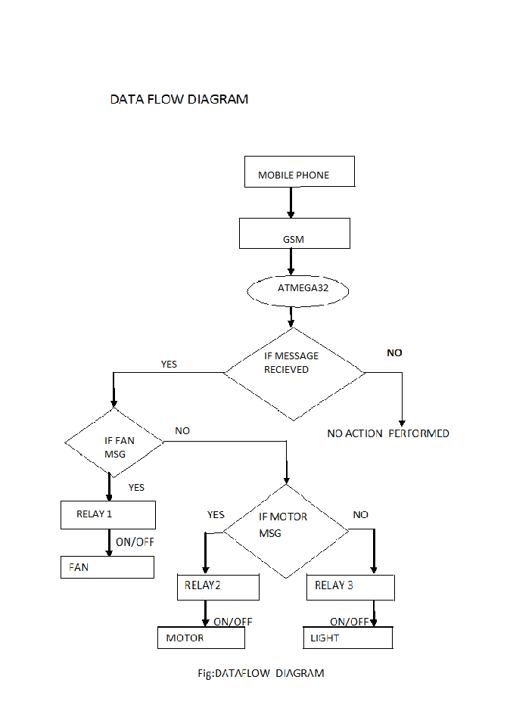

3.2 SCREEN SHOTS

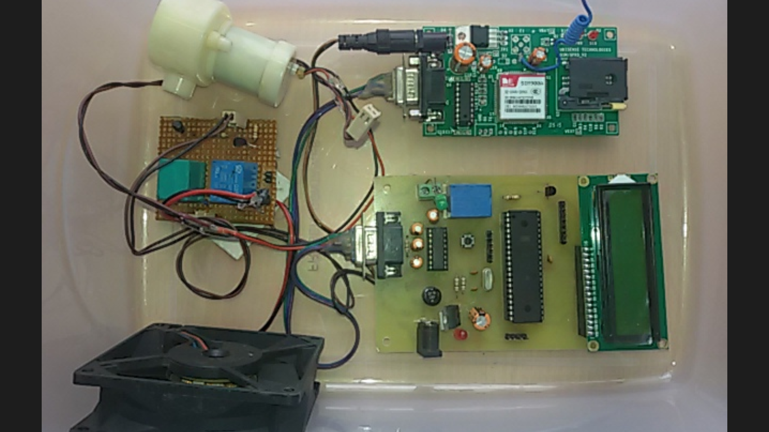

Fig No:3.2.1 Model of Smart Home Device.

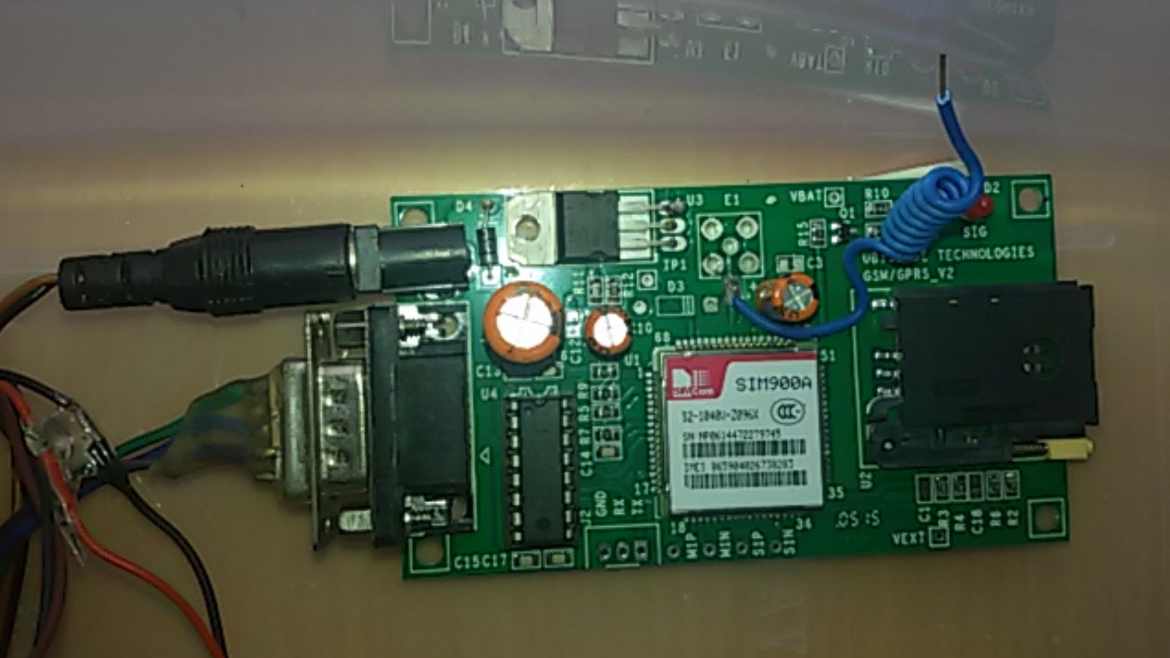

Fig No:3.2.2 Working model of GSM.

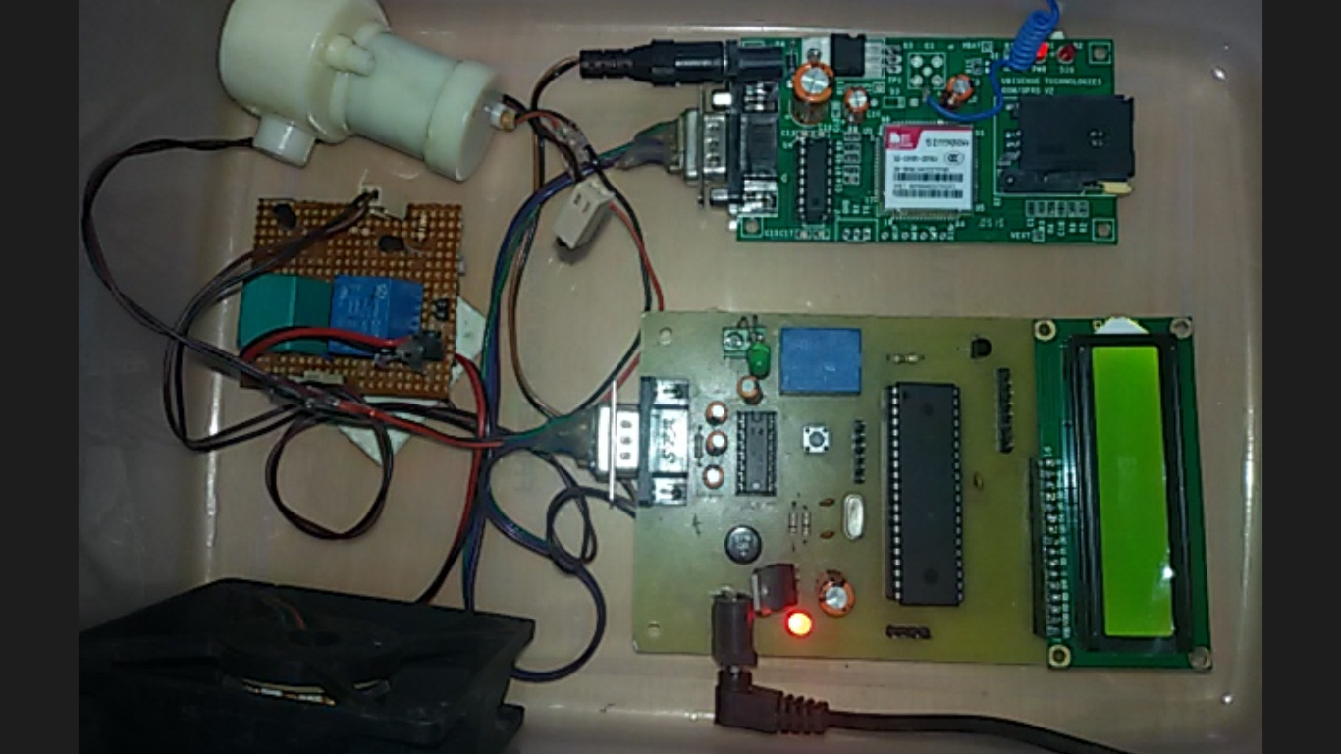

Fig No:3.2.3 Working model of smart home device.

Firstly ,when we send a message to the SIM number inserted in the GSM ,the

GSM receive the message and display it on the LCD screen .Then the circuit is

active the device which we wish to control can be handled.

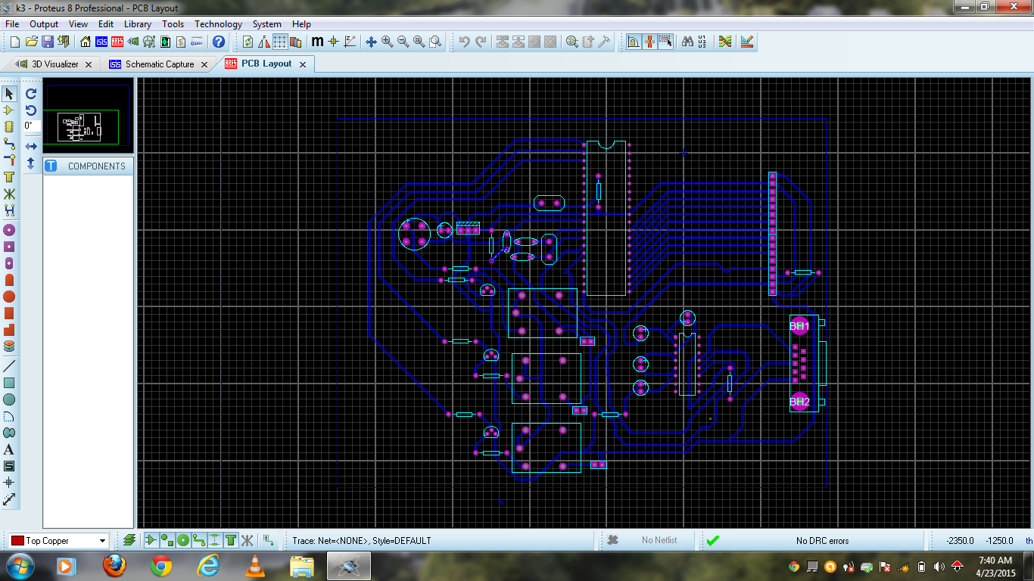

Fig No:3.2.4 PCB Layout Design

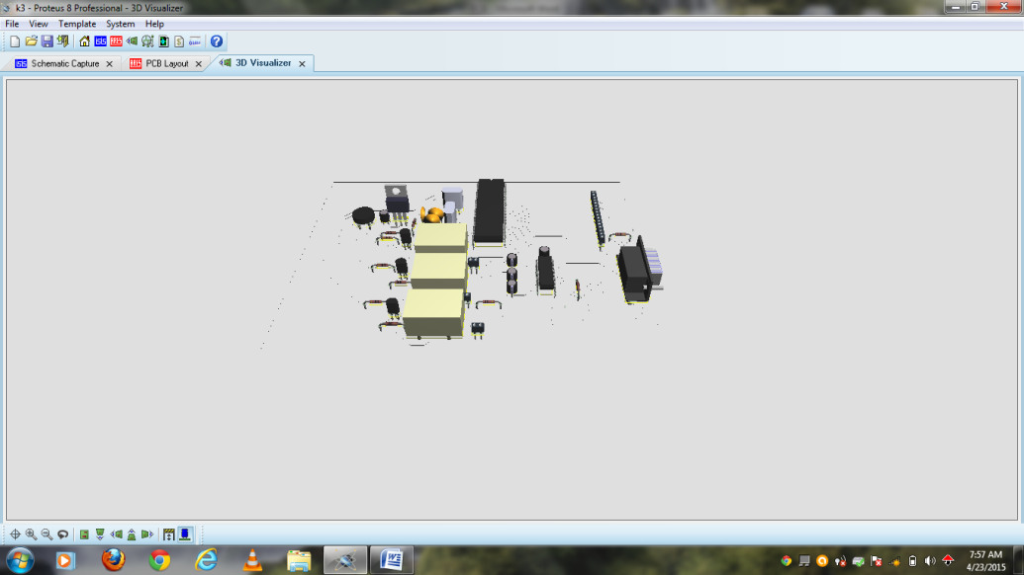

**Fig:3.2.5 3D Visualizer**

**3.3 MODULE DESCRIPTION**

The SMART HOME project consist of 4 modules. Each of these modules contribute different functions to the operation of the system.

* **POWER SUPPLY**

A **power supply** is an electronic device that supplies [electric energy](about:blank) to an [electrical load](about:blank). The primary function of a power supply is to convert one form of electrical energy to another and, as a result, power supplies are sometimes referred to as [electric power converters](about:blank). Some power supplies are discrete, stand-alone devices, whereas others are built into larger devices along with their loads. Examples of the latter include power supplies found in [desktop computers](about:blank) and [consumer electronics](about:blank) devices.

Every power supply must obtain the energy it supplies to its load, as well as any energy it consumes while performing that task, from an energy source. Depending on its design, a power supply may obtain energy from various types of energy sources, including electrical energy transmission systems, [energy storage](about:blank) devices such as a [batteries](about:blank) and [fuel cells](about:blank), electromechanical systems such as [generators](about:blank) and [alternators](about:blank), [solar power](about:blank) converters, or another power supply.

All power supplies have a power input, which receives energy from the energy source, and a power output that delivers energy to the load. In most power supplies the power input and output consist of [electrical connectors](about:blank) or hardwired circuit connections, though some power supplies employ [wireless energy transfer](about:blank) in lieu of galvanic connections for the power input or output. Some power supplies have other types of inputs and outputs as well, for functions such as external monitor and control.

|  |  |
| --- | --- |
|  |  |

[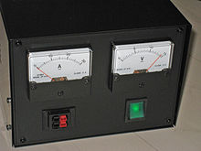](about:blank)

Fig No:3.3.1A simple desktop power supply

Power supplies are categorized in various ways, including by functional features. For example, a [regulated power supply](about:blank) is one that maintains constant output voltage or current despite variations in load current or input voltage. Conversely, the output of an unregulated power supply can change significantly when its input voltage or load current changes. Adjustable power supplies allow the output voltage or current to be programmed by mechanical controls (e.g., knobs on the power supply front panel), or by means of a control input, or both. An adjustable regulated power supply is one that is both adjustable and regulated. An isolated power supply has a power output that is electrically independent of its power input; this is in contrast to other power supplies that share a common connection between power input and output.

|  |  |
| --- | --- |
| Power supplies are packaged in different ways and classified accordingly. A bench power supply is a stand-alone desktop unit used in applications such as circuit test and development. Open frame power supplies have only a partial mechanical enclosure, sometimes consisting of only a mounting base; these are typically built into machinery or other equipment. Rack mount power supplies are designed to be secured into standard electronic equipment racks.  Power supplies can be broadly divided into linear and switching types. Linear power converters process the input power directly, with all active power conversion components operating in their linear operating regions. In switching power converters, the input power is converted to AC or to DC pulses before processing, by components that operate predominantly in non-linear modes (e.g., transistors that spend most of their time in cutoff or saturation). Power is "lost" (converted to heat) when components operate in their linear regions and, consequently, switching converters are usually more efficient than linear converters because their components spend less time in linear operating regions. |  |

### DC power supply

A DC power supply is one that supplies a voltage of fixed polarity (either positive or negative) to its load. Depending on its design, a DC power supply may be powered from a DC source or from an [AC](about:blank) source such as the power mains.

#### AC-to-DC supply

[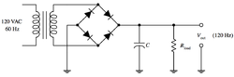](about:blank)

Some DC power supplies use AC [mains electricity](about:blank) as an energy source. Such power supplies will sometimes employ a [transformer](about:blank) to convert the input voltage to a higher or lower AC voltage. A [rectifier](about:blank) is used to convert the transformer output voltage to a varying DC voltage, which in turn is passed through an [electronic filter](about:blank) to convert it to an unregulated DC voltage. The filter removes most, but not all of the AC voltage variations; the remaining voltage variations are known as ripple. The electric load's tolerance of ripple dictates the minimum amount of filtering that must be provided by a power supply. In some applications, high ripple is tolerated and therefore no filtering is required

**AC power supplies**

An AC power supply typically takes the voltage from a wall outlet ([mains supply](about:blank)) and lowers it to the desired voltage. Some filtering may take place as well.

The suitability of a particular power supply for an application is determined by various attributes of the power supply, which are listed in the power supply's specification. Commonly specified attributes for a power supply include:

* Input voltage type (AC or DC) and range
* Efficiency of power conversion
* The amount of [voltage](about:blank) and [current](about:blank) it can supply to its load
* How stable its output voltage or current is under varying line and load conditions
* How long it can supply energy without refueling or recharging (applies to power supplies that employ portable energy sources)
* Operating and storage temperature ranges
* **CONTROLLER MODULE**

**ATmega32**

The major heart of this project is microcontroller; a microcontroller is a small computer on a single integrated circuit containing a processor core, memory, and programmable input/output peripherals etc. However, compare to others microcontroller is fast and very ease to program in C language because of huge support can gain from the manufacturer for programming.

[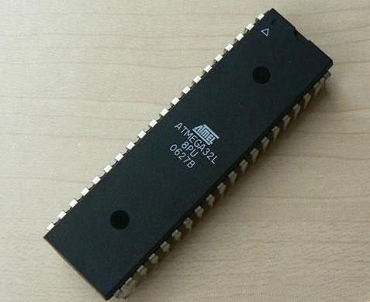](about:blank)

Fig No:3.3.2 ATmega32

Overview

The Atmel®AVR® ATmega32A is a low-power CMOS 8-bit microcontroller based on the AVR enhanced RISC architecture. By executing powerful instructions in a single clock cycle, the ATmega32A achieves throughputs approaching 1 MIPS per MHz allowing the system designer to optimize power consumption versus processing speed.

The Atmel®AVR® core combines a rich instruction set with 32 general purpose working registers. All the 32 registers are directly connected to the Arithmetic Logic Unit (ALU), allowing two independent registers to be accessed in one single instruction executed in one clock cycle. The resulting architecture is more code efficient while achieving throughputs up to ten times faster than conventional CISC microcontrollers.

The ATmega32A provides the following features: 32Kbytes of In-System Programmable Flash Program memory with Read-While-Write capabilities, 1024bytes EEPROM, 2Kbyte SRAM, 32 general purpose I/O lines, 32 general purpose working registers, a JTAG interface for Boundary-scan, On-chip Debugging support and programming, three flexible Timer/Counters with compare modes, Internal and External Interrupts, a serial programmable USART, a byte oriented Two-wire Serial Interface, an 8-channel, 10-bit ADC with optional differential input stage with programmable gain (TQFP package only), a programmable Watchdog Timer with Internal Oscillator, an SPI serial port, and six software selectable power saving modes. The Idle mode stops the CPU while allowing the USART, Two-wire interface, A/D Converter, SRAM, Timer/Counters, SPI port, and interrupt system to continue functioning. The Power-down mode saves the register contents but freezes the Oscillator, disabling all other chip functions until the next External Interrupt or Hardware Reset. In Power-save mode, the Asynchronous Timer con- tinues to run, allowing the user to maintain a timer base while the rest of the device is sleeping. The ADC Noise Reduction mode stops the CPU and all I/O modules except Asynchronous Timer and ADC, to minimize switching noise during ADC conversions. In Standby mode, the crystal/resonator Oscillator is running while the rest of the device is sleeping. This allows very fast start-up combined with low-power with low-power consumption. In Extended Standby mode, both the main Oscillator and the Asynchronous Timer continue to run.

The device is manufactured using Atmel’s high density nonvolatile memory technology. The On-chip ISP Flash allows the program memory to be reprogrammed in-system through an SPI serial interface, by a conventional non- volatile memory programmer, or by an On-chip Boot program running on the AVR core. The boot program can use any interface to download the application program in the Application Flash memory. Software in the Boot Flash section will continue to run while the Application Flash section is updated, providing true Read-While-Write opera- tion. By combining an 8-bit RISC CPU with In-System Self-Programmable Flash on a monolithic chip, the Atmel ATmega32A is a powerful microcontroller that provides a highly-flexible and cost-effective solution to many embedded control applications.The Atmel AVR ATmega32A is supported with a full suite of program and system development tools including: C compilers, macro assemblers, program debugger/simulators, in-circuit emulators, and evaluation kits.

* **DRIVER CIRCUIT**

In [electronics](about:blank), a **driver** is an [electrical circuit](about:blank) or other [electronic component](about:blank) used to control another circuit or component, such as a high-power [transistor](about:blank), [liquid crystal display (LCD)](about:blank), and numerous others.

They are usually used to regulate current flowing through a circuit or is used to control the other factors such as other components, some devices in the circuit. The term is often used, for example, for a specialized [integrated circuit](about:blank) that controls high-power [switches](about:blank) in switched-mode [power converters](about:blank). An [amplifier](about:blank) can also be considered a driver for [loudspeakers](about:blank), or a [constant voltage](about:blank) circuit that keeps an attached component operating within a broad range of input [voltages](about:blank). Typically the driver stages of a circuit requires different characteristics to other circuit stages. For example in a transistor power amplifier, typically the driver circuit requires current gain, often the ability to discharge the following transistor bases rapidly, and low output impedance to avoid or minimize distortion.

[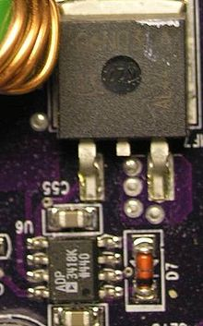](about:blank)

Fig No:3.3.3 A Simple driver circuit

* **LIQUID CRYSTAL DISPLAY**

A **liquid-crystal display** (**LCD**) is a [flat panel display](about:blank), [electronic visual display](about:blank), or [video display](about:blank) that uses the light modulating properties of [liquid crystals](about:blank). Liquid crystals do not emit light directly. LCDs are available to display arbitrary images (as in a general-purpose computer display) or fixed images which can be displayed or hidden, such as preset words, digits, and [7-segment](about:blank) displays as in a [digital clock](about:blank). They use the same basic technology, except that arbitrary images are made up of a large number of small [pixels](about:blank), while other displays have larger elements.

LCDs are used in a wide range of applications including [computer monitors](about:blank), televisions, [instrument panels](about:blank), [aircraft cockpit displays](about:blank), and signage. They are common in consumer devices such as DVD players, gaming devices, [clocks](about:blank), [watches](about:blank), [calculators](about:blank), and telephones, and have replaced [cathode ray tube](about:blank) (CRT) displays in most applications. They are available in a wider range of screen sizes than CRT and [plasma displays](about:blank), and since they do not use phosphors, they do not suffer [image burn-in](about:blank). LCDs are, however, susceptible to [image persistence](about:blank).[[2]](about:blank#cite_note-Fujitsu-2)

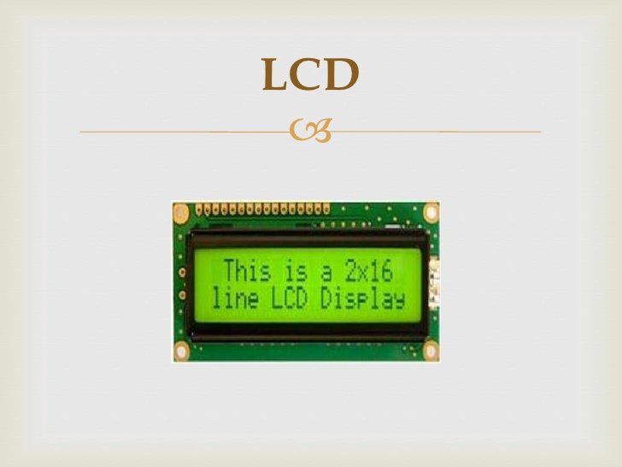

Fig No: 3.3.4 2\*16 LCD Display

* **ELECTRONIC FILTER**

**Electronic filters** are [analog circuits](about:blank) which perform [signal processing](about:blank) functions, specifically to remove unwanted frequency components from the signal, to enhance wanted ones, or both. Electronic [filters](about:blank) can be: [passive](about:blank) or [active](about:blank), [analog](about:blank) or [digital](about:blank), [high-pass](about:blank), [low-pass](about:blank), [band-pass](about:blank), [band-stop](about:blank) (band-rejection; notch), or [all-pass](about:blank), [discrete-time](about:blank) (sampled) or [continuous-time](about:blank), [linear](about:blank) or [non-linear](about:blank), [infinite impulse response](about:blank) (IIR type) or [finite impulse response](about:blank) . The most common types of electronic filters are [linear filters](about:blank), regardless of other aspects of their design.

[Passive analogue filter development](about:blank) is the oldest forms of electronic filters are passive analog linear filters, constructed using only [resistors](about:blank) and [capacitors](about:blank) or resistors and [inductors](about:blank). These are known as RC and RL single-[pole](about:blank) filters respectively. More complex multipole LC filters have also existed for many years, and their operation is well understood.

* **VOLTAGE REGULATER**

[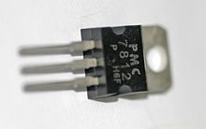](about:blank)

Fig No:3.3.5 Voltage Regulator

A **voltage regulator** is designed to automatically maintain a [constant voltage](about:blank) level. A voltage regulator may be a simple "[feed-forward](about:blank)" design or may include [negative feedback](about:blank) [control loops](about:blank). It may use an electromechanical [mechanism](about:blank), or electronic components. Depending on the design, it may be used to regulate one or more [AC](about:blank) or [DC](about:blank) voltages.

Electronic voltage regulators are found in devices such as computer [power supplies](about:blank) where they stabilize the DC voltages used by the processor and other elements. In automobile [alternators](about:blank) and central [power station](about:blank) generator plants, voltage regulators control the output of the plant. In an [electric power distribution](about:blank) system, voltage regulators may be installed at a substation or along distribution lines so that all customers receive steady voltage independent of how much power is drawn from the line. The regulation is specified by two measurements:

**load regulation** is the change in output voltage for a given change in load current (for example: "typically 15 mV, maximum 100 mV for load currents between 5 mA and 1.4 A, at some specified temperature and input voltage").

# GSM (GLOBAL SYSTEM FOR MOBILES)

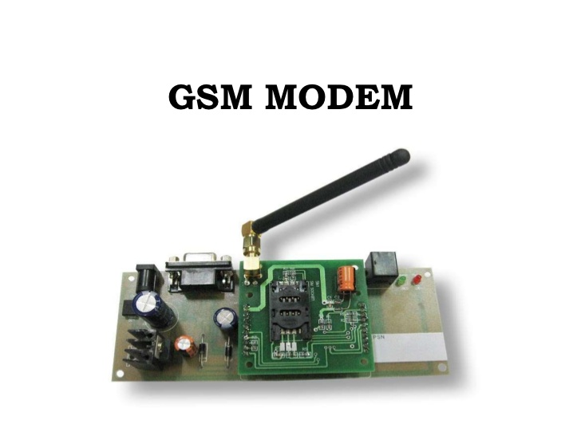

Fig No:3.3.6 A GSM Modem

The GSM logo is used to identify compatible handsets and equipment. The dots symbolize three clients in the home network and one roaming client.

GSM (Global System for Mobile Communications, originally Groupe Spécial Mobile), is a standard developed by the European Telecommunications Standards Institute (ETSI) to describe protocols for second-generation (2G) digital cellular networks used by mobile phones. As of 2014 it has become the default global standard for mobile communications - with over 90% market share, operating in over 219 countries and territories.

2G networks developed as a replacement for first generation (1G) analog cellular networks, and the GSM standard originally described a digital, circuit-switched network optimized for full duplex voice telephony. This expanded over time to include data communications, first by circuit-switched transport, then by packet data transport via GPRS (General Packet Radio Services) and EDGE (Enhanced Data rates for GSM Evolution or EGPRS).

Subsequently, the 3GPP developed third-generation (3G) UMTS standards followed by fourth-generation (4G) LTE Advanced standards, which do not form part of the ETSI GSM standard.

"GSM" is a trademark owned by the GSM Association. It may also refer to the (initially) most co mmon voice codec used, Full Rate.

## Technical details

[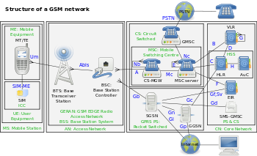](about:blank)

Fig No: 3.3.7 The structure of a GSM network

### Network structure

The network is structured into a number of discrete sections:

* Base Station Subsystem – the base stations and their controllers explained
* Network and Switching Subsystem – the part of the network most similar to a fixed network, sometimes just called the "core network"
* GPRS Core Network – the optional part which allows packet-based Internet connections
* Operations support system (OSS) – network maintenance

### Base station subsystem

[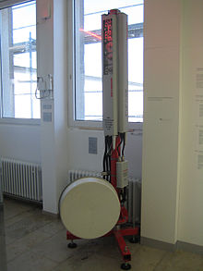](about:blank)

Fig No:3.3.8 GSM cell site antennas in the Deutsches Museum, Munich, Germany

GSM is a cellular network, which means that cell phones connect to it by searching for cells in the immediate vicinity. There are five different cell sizes in a GSM network—macro, micro, pico, femto, and umbrella cells. The coverage area of each cell varies according to the implementation environment. Macro cells can be regarded as cells where the base station antenna is installed on a mast or a building above average rooftop level. Micro cells are cells whose antenna height is under average rooftop level; they are typically used in urban areas. Picocells are small cells whose coverage diameter is a few dozen metres; they are mainly used indoors. Femtocells are cells designed for use in residential or small business environments and connect to the service provider’s network via a broadband internet connection. Umbrella cells are used to cover shadowed regions of smaller cells and fill in gaps in coverage between those cells.

Cell horizontal radius varies depending on antenna height, antenna gain, and propagation conditions from a couple of hundred meters to several tens of kilometres. The longest distance the GSM specification supports in practical use is 35 kilometres (22 mi). There are also several implementations of the concept of an extended cell,here the cell radius could be double or even more, depending on the antenna system, the type of terrain, and the timing advance.

Indoor coverage is also supported by GSM and may be achieved by using an indoor picocell base station, or an indoor repeater with distributed indoor antennas fed through power splitters, to deliver the radio signals from an antenna outdoors to the separate indoor distributed antenna system. These are typically deployed when significant call capacity is needed indoors, like in shopping centers or airports. However, this is not a prerequisite, since indoor coverage is also provided by in-building penetration of the radio signals from any nearby cell.

#### GSM carrier frequencies

Main art GSM frequency bands

GSM networks operate in a number of different carrier frequency ranges (separated into GSM frequency ranges for 2G and UMTS frequency bands for 3G), with most 2G GSM networks operating in the 900 MHz or 1800 MHz bands. Where these bands were already allocated, the 850 MHz and 1900 MHz bands were used instead (for example in Canada and the United States). In rare cases the 400 and 450 MHz frequency bands are assigned in some countries because they were previously used for first-generation systems.

Most 3G networks in Europe operate in the 2100 MHz frequency band. For more information on worldwide GSM frequency usage, see GSM frequency bands.

Regardless of the frequency selected by an operator, it is divided into timeslots for individual phones. This allows eight full-rate or sixteen half-rate speech channels per radio frequency. These eight radio timeslots (or burst periods) are grouped into a TDMA frame. Half-rate channels use alternate frames in the same timeslot. The channel data rate for all 8 channels is 270.833 kbit/s, and the frame duration is 4.615 ms.

The transmission power in the handset is limited to a maximum of 2 watts in GSM 850/900 and 1 watt in GSM 1800/1900.

#### Voice codes

GSM has used a variety of voice codecs to squeeze 3.1 kHz audio into between 6.5 and 13 kbit/s. Originally, two codecs, named after the types of data channel they were allocated, were used, called Half Rate (6.5 kbit/s) and Full Rate (13 kbit/s). These used a system based on linear predictive coding (LPC). In addition to being efficient with bitrates, these codecs also made it easier to identify more important parts of the audio, allowing the air interface layer to prioritize and better protect these parts of the signal.

As GSM was further enhanced in 1997 with the Enhanced Full Rate (EFR) codec, a 12.2 kbit/s codec that uses a full-rate channel. Finally, with the development of UMTS, EFR was refactored into a variable-rate codec called AMR-Narrowband, which is high quality and robust against interference when used on full-rate channels, or less robust but still relatively high quality when used in good radio conditions on half-rate channel.

### Subscriber Identity Module (SIM)

One of the key features of GSM is the Subscriber Identity Module, commonly known as a **SIM card**. The SIM is a detachable smart card containing the user's subscription information and phone book. This allows the user to retain his or her information after switching handsets. Alternatively, the user can also change operators while retaining the handset simply by changing the SIM. Some operators will block this by allowing the phone to use only a single SIM, or only a SIM issued by them; this practice is known as SIM locking.

### Phone locking

### SIM lock

Sometimes mobile network operators restrict handsets that they sell for use with their own network. This is called *locking* and is implemented by a software feature of the phone. A subscriber may usually contact the provider to remove the lock for a fee, utilize private services to remove the lock, or use software and websites to unlock the handset themselves.

In some countries (e.g., Bangladesh, Brazil, Chile, Germany, Hong Kong, India, Iran, Lebanon, Malaysia, Nepal, Pakistan, Singapore, South Africa) all phones are sold unlocked.

### GSM service security

UMTS security

GSM was designed with a moderate level of service security. The system was designed to authenticate the subscriber using a pre-shared key and challenge-response. Communications between the subscriber and the base station can be encrypted. The development of UMTS introduces an optional Universal Subscriber Identity Module (USIM), that uses a longer authentication key to give greater security, as well as mutually authenticating the network and the user, whereas GSM only authenticates the user to the network (and not vice versa). The security model therefore offers confidentiality and authentication, but limited authorization capabilities, and no non-repudiation.

GSM uses several cryptographic algorithms for security. The A5/1, A5/2, and A5/3 stream ciphers are used for ensuring over-the-air voice privacy. A5/1 was developed first and is a stronger algorithm used within Europe and the United States; A5/2 is weaker and used in other countries. Serious weaknesses have been found in both algorithms: it is possible to break A5/2 in real-time with a ciphertext-only attack, and in January 2007, The Hacker's Choice started the A5/1 cracking project with plans to use FPGAs that allow A5/1 to be broken with a rainbow table attack. The system supports multiple algorithms so operators may replace that cipher with a stronger one.

On 28 December 2009 German computer engineer Karsten Nohl announced that he had cracked the A5/1 cipher. According to Nohl, he developed a number of rainbow tables (static values which reduce the time needed to carry out an attack) and have found new sources for known plainte attacks. He also said that it is possible to build "a full GSM interceptor...from open-source components" but that they had not done so because of legal concerns. Nohl claimed that he was able to intercept voice and text conversations by impersonating another user to listen to voicemail, make calls, or send text messages using a seven-year-old Motorola cellphone and decryption software available for free online.

New attacks have been observed that take advantage of poor security implementations, architecture, and development for smartphone applications. Some wiretapping and eavesdropping techniques hijack the audio input and output providing an opportunity for a third party to listen in to the conversation.

GSM uses General Packet Radio Service (GPRS) for data transmissions like browsing the web. The most commonly deployed GPRS ciphers were publicly broken in 2011.

The researchers revealed flaws in the commonly used GEA/1 and GEA/2 ciphers and published the open-source "gprsdecode" software for sniffing GPRS networks. They also noted that some carriers do not encrypt the data (i.e., using GEA/0) in order to detect the use of traffic or protocols they do not like (e.g., Skype), leaving customers unprotected. GEA/3 seems to remain relatively hard to break and is said to be in use on some more modern networks. If used with USIM to prevent connections to fake base stations and downgrade attacks, users will be protected in the medium term, though migration to 128-bit GEA/4 is still recommended.

## Standards information

The GSM systems and services are described in a set of standards governed by ETSI, where a full list is maintained.

## GSM open-source software

Several open-source software projects exist that provide certain GSM features:

* gsmd daemon by Openmoko
* OpenBTS develops a Base transceiver station
* The GSM Software Project aims to build a GSM analyzer for less than $1,000
* OsmocomBB developers intend to replace the proprietary baseband GSM stack with a free software implementation
* YateBTS develops a Base transceiver station
* **MAX232**

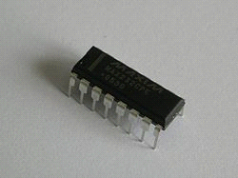

Fig No:3.3.9 A MAX232 IC

The MAX232 is an IC, first created in 1987 by Maxim Integrated Products, that converts signals from an RS-232 serial port to signals suitable for use in TTL compatible digital logic circuits. The MAX232 is a dual driver/receiver and typically converts the RX, TX, CTS and RTS signals.The drivers provide RS-232 voltage level outputs (approx. ± 7.5 V) from a single + 5 V supply via on-chip charge pumps and external capacitors. This makes it useful for implementing RS-232 in devices that otherwise do not need any voltages outside the 0 V to + 5 V range, as power supply design does not need to be made more complicated just for driving the RS-232 in this case.The receivers reduce RS-232 inputs (which may be as high as ± 25 V), to standard 5 V TTL levels. These receivers have a typical threshold of 1.3 V, and a typical hysteresis of 0.5 V

Versions

The later MAX232A is backwards compatible with the original MAX232 but may operate at higher baud rates and can use smaller external capacitors – 0.1 μF in place of the 1.0 μF capacitors used with the original device.[1] The newer MAX3232 is also backwards compatible, but operates at a broader voltage range, from 3 to 5.5 V. [2] Pin-to-pin compatible versions from other manufacturers are ICL232, ST232, ADM232 and HIN232.

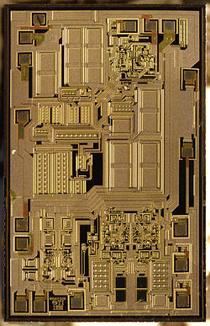

Fig No:3.3.10 MAX 232

Voltage levels

It is helpful to understand what occurs to the voltage levels. When a MAX232 IC receives a TTL level to convert, it changes a TTL logic 0 to between +3 and +15 V, and changes TTL logic 1 to between -3 to -15 V, and vice versa for converting from RS232 to TTL. This can be confusing when you realize that the RS232 data transmission voltages at a certain logic state are opposite from the RS232 control line voltages at the same logic state. To clarify the matter, see the table below. For more information, see RS-232 voltage levels.

Applications

RS-232 to TTL converters, using MAX232 The MAX232(A) has two receivers (converts from RS-232 to TTL voltage levels), and two drivers (converts from TTL logic to RS-232 voltage levels). This means only two of the RS-232 signals can be converted in each direction. Typically, a pair of a driver/receiver of the MAX232 is used for TX and RX signals, and the second one for CTS and RTS signals.There are not enough drivers/receivers in the MAX232 to also connect the DTR, DSR, and DCD signals. Usually these signals can be omitted when e.g. communicating with a PC's serial interface. If the DTE really requires these signals, either a second MAX232 is needed, or some other IC from the MAX232 family can be used. Also, it is possible to directly wire DTR (DB9 pin #4) to DSR (DB9 pin #6) without going through any circuitry. This gives automatic (brain dead) DSR acknowledgment of an incoming DTR signal.

|  |
| --- |
| * **Crystal oscillator** |
| [C:\Users\LENOVO\Downloads\Crystal oscillator - Wikipedia, the free encyclopedia_files\220px-18MHZ_12MHZ_Crystal_110.jpg](about:blank)  Fig No:3.3.11 Quartz crystal resonator (left) and quartz crystal oscillator (right) |

A **crystal oscillator** is an [electronic oscillator](about:blank) circuit that uses the mechanical [resonance](about:blank) of a vibrating [crystal](about:blank) of [piezoelectric material](about:blank#Materials) to create an electrical signal with a very precise [frequency](about:blank).[[1]](about:blank#cite_note-Graf-1)[[2]](about:blank#cite_note-Amos-2)[[3]](about:blank#cite_note-Laplante-3) This frequency is commonly used to keep track of time (as in [quartz wristwatches](about:blank)), to provide a stable [clock signal](about:blank) for [digital](about:blank) [integrated circuits](about:blank), and to stabilize frequencies for [radio transmitters](about:blank) and [receivers](about:blank). The most common type of piezoelectric resonator used is the [quartz](about:blank) crystal, so oscillator circuits incorporating them became known as crystal oscillators,[[1]](about:blank#cite_note-Graf-1) but other piezoelectric materials including polycrystalline ceramics are used in similar circuits.

Quartz crystals are manufactured for frequencies from a few tens of [kilohertz](about:blank) to hundreds of megahertz. More than two billion crystals are manufactured annually. Most are used for consumer devices such as [wristwatches](about:blank), [clocks](about:blank), [radios](about:blank), [computers](about:blank), and [cellphones](about:blank). Quartz crystals are also found inside test and measurement equipment, such as counters, [signal generators](about:blank), and [oscilloscopes](about:blank).

## Operation

A [crystal](about:blank) is a [solid](about:blank) in which the constituent [atoms](about:blank), [molecules](about:blank), or [ions](about:blank) are packed in a regularly ordered, repeating pattern extending in all three spatial dimensions.

Almost any object made of an [elastic](about:blank) material could be used like a crystal, with appropriate [transducers](about:blank), since all objects have natural [resonant](about:blank) frequencies of [vibration](about:blank). For example, [steel](about:blank) is very elastic and has a high speed of sound. It was often used in [mechanical filters](about:blank) before quartz. The resonant frequency depends on size, shape, [elasticity](about:blank), and the [speed of sound](about:blank) in the material. High-frequency crystals are typically cut in the shape of a simple, rectangular plate. Low-frequency crystals, such as those used in digital watches, are typically cut in the shape of a [tuning fork](about:blank). For applications not needing very precise timing, a low-cost [ceramic resonator](about:blank) is often used in place of a quartz crystal.

When a crystal of [quartz](about:blank) is properly cut and mounted, it can be made to distort in an [electric field](about:blank) by applying a [voltage](about:blank) to an [electrode](about:blank) near or on the crystal. This property is known as [electrostriction](about:blank) or inverse piezoelectricity. When the field is removed, the quartz will generate an electric field as it returns to its previous shape, and this can generate a voltage. The result is that a quartz crystal behaves like a circuit composed of an [inductor](about:blank), [capacitor](about:blank) and [resistor](about:blank), with a precise resonant frequency. (See [RLC circuit](about:blank).)

Quartz has the further advantage that its elastic constants and its size change in such a way that the frequency dependence on temperature can be very low. The specific characteristics will depend on the mode of vibration and the angle at which the quartz is cut (relative to its crystallographic axes).[[11]](about:blank#cite_note-Virgil1982-11) Therefore, the resonant frequency of the plate, which depends on its size, will not change much, either. This means that a quartz clock, filter or oscillator will remain accurate. For critical applications the quartz oscillator is mounted in a temperature-controlled container, called a [crystal oven](about:blank), and can also be mounted on shock absorbers to prevent perturbation by external mechanical vibrations.

* **RESET**

Reset is used for putting the microcontroller into a 'known' condition. That practically means that microcontroller can behave rather inaccurately under certain undesirable conditions. In order to continue its proper functioning it has to be reset, meaning all registers would be placed in a starting position. Reset is not only used when microcontroller doesn't behave the way we want it to, but can also be used when trying out a device as an interrupt in program execution, or to get a microcontroller ready when loading a program.

* **RECTIFIER**

A rectifier is an electrical device that [converts](about:blank) [alternating current](about:blank) (AC), which periodically reverses direction, to [direct current](about:blank) (DC), which flows in only one direction. The process is known as rectification. Physically, rectifiers take a number of forms, including [vacuum tube](about:blank) [diodes](about:blank), [mercury-arc valves](about:blank), copper and selenium oxide rectifiers, [semiconductor diodes](about:blank), [silicon-controlled rectifiers](about:blank) and other silicon-based semiconductor switches. Historically, even synchronous electromechanical switches and motors have been used. Early radio receivers, called [crystal radios](about:blank), used a "[cat's whisker](about:blank)" of fine wire pressing on a crystal of [galena](about:blank) (lead sulfide) to serve as a point-contact rectifier or "crystal detector". Rectifiers have many uses, but are often found serving as components of DC [power supplies](about:blank) and [high-voltage direct current](about:blank) power transmission systems. Rectification may serve in roles other than to generate direct current for use as a source of power. As noted, [detectors](about:blank) of [radio](about:blank) signals serve as rectifiers. In gas heating systems [flame rectification](about:blank) is used to detect presence of flame.

**Step-down Transformer**



Fig No:3.3.12 Step-down Transformer

A step down transformer has less turns on the secondary coil that the primary coil. The induced voltage across the secondary coil is less the applied voltage across the primary coil or in other words the voltage is “stepped-down”.Transformers are very efficient. If it is assumed that a transformer is 100% efficient (and this is a safe assumption as transformers may be up to 99% efficient) then the power in the primary coil has to be equal to the power in the secondary coil, as per the law of conservation of energy.

Power in primary coil = Power in secondary coil

Remember, power = potential difference x current

Thus,Primary coil p.d. x primary coil current = Secondary coil p.d. x secondary coil current

VP x IP = VS x IS

So if the potential difference is stepped up by a transformer then the current is stepped down by roughly the same ratio. In the case of the potential being stepped down by the transformer then the current is stepped up by the same ratio.

**4 .SYSTEM TEST PLAN**

Software testing is the process of checking software, to verify that it satisfies its requirements and to detect errors. Software testing is an empirical investigation conducted to provide stakeholders with information about the quality of the product or service under test[1] , with respect to the context in which it is intended to operate. This includes, but is not limited to, the process of executing a program or application with the intent of finding software bugs. Testing can never completely establish the correctness of computer software. Instead, it furnishes a criticism or comparison that compares the state and behavior of the product against a specification. Software testing should be distinguished from the separate discipline of Software Quality Assurance (S.Q.A.), which encompasses all business process areas, not just testing.

Embedded systems is gaining importance with increasing adoption of 16 and 32-bit processors across a wide variety of electronic products. As consumer expectation from these systems grow, manufacturers are challenged with the following factors before testing this to perfect for market release:

* Real time responses
* Separate host (target) systems from development environments
* Lack of standardization in deployment architectures
* Lack of established interfaces to systems under testing
* Stringent Fail-Safe requirements
* Extremely high cost of isolating and fixing defects

Calsoft Labs provides end-to-end testing services for embedded software & hardware across a gadgets/devices, Real Time Operating Systems (RTOS), development platforms, and programming languages. Our services include embedded software & hardware testing strategy and code-level testing, as well as coverage analysis, functional testing, stress testing, code review, debugging, and code maintenance.

Calsoft labs’ well defined Testing Services practice covering the entire spectrum from semiconductor, firmware, middleware/ protocols and system & application level tests. Our robust test automation framework is suitable to address testing challenges for the embedded systems of industries like Networking, Communications, Storage, Consumer Electronics & Multimedia, Industrial Automation, Computer Hardware & Peripherals and Automotive Electronics.

The testing services spectrum covers entire value chain including:

* System Level Testing
* Application Testing
* Middleware Testing
* BSP & Driver testing
* Embedded Hardware Design Testing

**5.TEST REPORT**

Testing is a very specialist skill and can take years to learn and perfect. There are many testing techniques and the tester needs to understand when and how to use them. But the tester's job is basically to ensure there are no dormant software bugs in the system, so the test cases they develop must be able to exercise the software in such a way as to uncover all the anomalies in the system. A lot of techniques for developing software cross over to firmware, where robustness and verification is equally important.

**MODEL-BASED TESTING FOR EMBEDDED SYSTEMS**

"As model-based testing is entering the mainstream, such a comprehensive and intelligible book is a must-read for anyone looking for more information about improved testing methods for embedded systems. Illustrated with numerous aspects of these techniques from many contributors, it gives a clear picture of what the state of the art is today."

* Clarifies theory and practice associated with test specification and validation of complex software-intensive embedded systems
* Includes detailed examples from industry to illustrate real-world solutions
* Provides a global view of the current practices in Model-Based Testing, helping engineers choose the most appropriate solution
* Presents model-based testing from various perspectives, combining aspects of embedded systems and software

Testing embedded software is as important as hardware test

Embedded software testing is a discipline that is both easier and more efficient if it can be conducted concurrently with software development, and preferably with the hardware. The extent to which this can be done varies.For example, ByteSnap, a design consultancy specialising in embedded system development, can be presented with projects at the concept level and so the complete design flow – hardware and software – is in its hands.

Resource Group, meanwhile, supplies engineering and support services to safety critical sectors. Typically, companies in these sectors want to retain the development work in house, but outsource the review, analysis and testing to Resource.

These two different starting points result in different processes, including how the software tests are created and executed. ByteSnap may start with a list of customer requirements, from which it will select a reference design, typically from one of the processor companies, that at least meets and most closely matches these requirements.

Graeme Wintle, director of ByteSnap, comments: "This board usually has additional features that we don't need, so we will develop a board based on this reference and will exclude the parts that we do not need. We do the same thing from the software point of view, taking the reference software and take out the drivers for the parts we have removed. This development then needs to be tested, because we have effectively made changes to the operating system, or at least the drivers to the OS. In this case, the easiest way of testing and debugging is a serial port to the device and that will provide pointers as to where the code is going wrong. That is the process. Obviously you try and start with something that is as close as possible to what you want the end product to be."

Any time someone is developing software with safety implications, they must adhere to industry standards and demonstrate compliance, which is where companies like Resource come in.

"Debugging is a process undertaken by the developer to demonstrate compliance to the requirements; it tends to be a demonstration of confidence in the developed system," said John Minihan, director of Resource Group's REP Systems and Solutions division. "Testing, or more importantly, verification (review, test and analysis), tends to be a more rigorous approach, often by an independent person, to demonstrate that the developed system conforms to standards, is robust and is functionally correct.

"Testing is a very specialist skill and can take years to learn and perfect. There are many testing techniques and the tester needs to understand when and how to use them. But the tester's job is basically to ensure there are no dormant software bugs in the system, so the test cases they develop must be able to exercise the software in such a way as to uncover all the anomalies in the system. A lot of techniques for developing software cross over to firmware, where robustness and verification is equally important."

Here, the start point is the architectural design and allocation of the flowed down requirements into high level blocks of common functionality (object orientation). The system can then be partitioned into smaller and smaller blocks of manageable functionality, with clear inputs and outputs, functional activity, data encapsulation and memory/timing constraints.

For high integrity software, testing is performed in stages. Low level test comes first, where the software/firmware modules are tested for functional correctness and robustness at their lowest level of decomposition. Often, low level test is run on a representative target to find errors in the compiler or features of the target environment not anticipated at design time.

The next stage is integration test, where blocks are combined into larger functions and tested end to end to verify that the higher level requirements are met and that the integrated modules work together. Integration testing will tend to find faults in scaling, timing, sequencing, scheduling and interconnects, as well as functional problems. A

secondary part of integration test can be hardware/software integration, where large chunks of the software (if not the entire software) are loaded onto the hardware (or representative blocks of hardware) and tested end to end against the high level requirements.

The final stage is the system level test, where the entire system is tested against the customer's requirements to demonstrate compliance to the specification.

As Minihan explained, while test development can start early in the process, it is not always advisable to put too much resource in straight away. "In an ideal world, once customer requirements are available, the tester can start developing their plans and strategies and even develop the test cases. As the design lifecycle continues, the tester can develop lower and lower level test cases until the actual code is produced. These test cases can then start to be executed and as more modules become available, they can be integrated and integration tests can start.

However, in reality, the design is likely to develop in an iterative process, so it is possible that tests developed too early will be superseded by design changes made at a later stage. For this reason, the early stages of a project deal with establishing the test vehicles, the test plan and methodologies; testing only starts in earnest once the development team has reasonable confidence in their developed components."

The low level tests for ByteSnap can be carried out through USB or Ethernet ports, if available, but this is not always the case, according to Wintle, who said there needs to be an element of 'design for debug', citing a case where a jack had to be included on prototypes, that wouldn't be on the production board, just to allow debug.

From there, the nature of the test depends on the operating system. Wintle said: "In a Linux environment, you have a command line shell over which you can issue commands. In a Windows CE environment, you don't have that level of connecting. What we would normally do is have a little terminal application that is running, talking over the serial link and asking for commands so we can do things like run a process, kill a process, list things that are running on a device – very simple driver level tests to see if the drivers are working."

Companies like ByteSnap, developing the system software and applications, can look to reduce development time with variations on reference designs and applications like its own interface framework, SnapUI. However, at the safety critical end of the market, Minihan issues a word of caution for those looking to use some of the newer debug tools or other 'shortcuts'. "Some of these newer tools use the actual code to develop the interfaces and can also run tester supplied inputs through the real code to suggest output values. If the tester is lazy and doesn't check correctly, you can easily end up with code generated tests testing the code. Ideally, testers should develop their own test cases and expected results directly from the requirements, then put them into the test tool and verify that the real code produces the expected results for the input stimulus."

When asked what is the best starting point for a successful project, Wintle replied: "Something that allows you to have a good way of debugging the application is a good start."

**6.** **CONCLUSION**

In the paper low cost, secure, ubiquitously accessible, auto-configurable, remotely controlled solution for automation of homes has been introduced.

The approach discussed in the paper is novel and has achieved the target to control home appliances remotely using the SMS -based system satisfying user needs and requirements. GSM technology capable solution has proved to be controlled remotely, provide home security and is cost-effective as compared to the previously existing systems. Hence we can conclude that the required goals and objectives of HACS have been achieved. The basic level of home appliance control and remote monitoring has been implemented. The system is extensible and more levels can be further developed using automatic motion/glass breaking detectors so the solution can be integrated with these and other detection systems. In case of remote monitoring other appliances can also be monitored such that if the level of temperature rises above certain level then it should generate SMS or sensors can also be applied that can detect gas, smoke or fire in case of emergency the system will automatically generate SMS. In future the system will be small box combining the PC and GSM modem. This hardware can be imported from Taiwan and Singapore.

**7. FUTURE SCOPE**

Information technology plays a key role in codifying knowledge and distributing it throughout the organization .Systems are created to solve problems. The system analysis and design mainly deals with the software development activities.

The proposed system is developed to overcome the drawbacks of the existing system. The main objective of the project is to control the home appliances from remote area according to the user wish .There are many devices for controlling devices but they are expensive.So here we use all basic components like GSM,SIM, mobile etc… to make our project easier. Remote control technologies are widely used to control household electronic appliances without walking up to them. The advantage of cellular technology is a potential solution for remote controlling activities.

Future enhancement are:

* It can be used to control the speed of the fan
* Controlling room temperature
* Recording our favorite TV when we are outside our home.
* It can be used for security purposes like
* Burglary
* Gas detection
* Smoke detection

**8.REFERENCES**

* **BOOKS**
* CraigZacker&John Rourke,”PC Hardware:The Complete Reference”.
* Barry B.Brey,”The Intel Microprocessor”.
* **WEBSITES**
* [www.embeddedprojects.com](about:blank)
* [www.wikipedia.com](about:blank)

**9. LIST OF ABBREVIATIONS**

**NO. Abbreviation Descriptions**

1. GSM Global System for Mobiles

2. SIM Subscriber Identity Module

3. LCD Liquid Crystal Display

4. ATMEGA32 Atmel Mega32